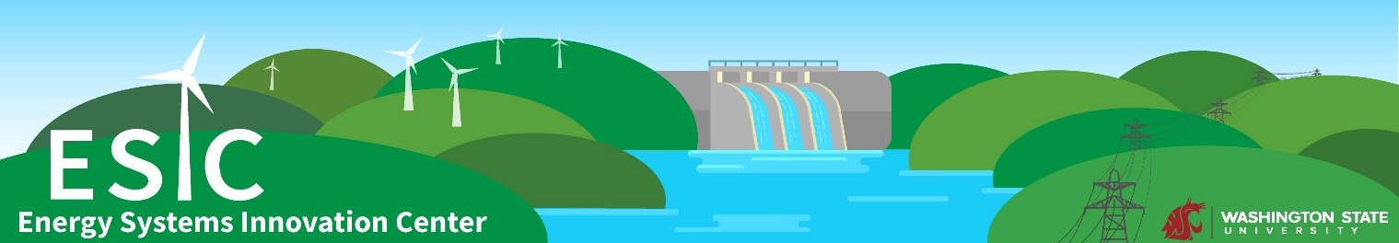

ESIC-AGI FA22 Power Seminar Series

Welcome & Introductions

Tuesday, August 30 • 11:00 AM – Noon • ETRL101

Tentative Agenda

- Welcome and graduate student rules – Dr. Mani Venkatasubramanian
- Student introductions
- Faculty and Staff introductions
- Why Power Industry? – Dr. Anjan Bose
- AGI, UI-ASSIST project, GSA (and student success) – Dr. Noel Schulz
- ESIC seminars – Dr. Anamika Dubey
- Q&A
- Pizza & Beverages (ETRL 119 – across the hall from ETRL 101)

